Pupil Attendance

Policy

“I am the vine; you are the branches.
If you remain in me and I in you, you will bear much fruit”

(John 15:5)

This is a model policy for all Vine schools that has been reviewed and adapted for St Nicholas CE Junior school.

Policy Reference: | A023
Approved by Vine Schools Trust on: | Summer 2022
Adopted by this school on:
Next review: | Autumn 2023

Vision & Values

V | Valuing every person
I | Inspiring great teaching
N | Nurturing academic excellence and Christian Character
E | Excelling, unlocking great potential

Introduction and Background

The Vine Schools Trust recognises that positive behaviour and good attendance are essential in order to raise standards of pupil attainment and to give every child/young person the best educational experience possible.

The law entitles every child of compulsory school age to an efficient, full-time education suitable to their age, aptitude, and any special educational need they may have. It is the legal responsibility of every parent to make sure their child receives that education either by attendance at a school or by education otherwise than at a school.

Where parents decide to have their child registered at school, they have an additional legal duty to ensure their child attends that school regularly. This means their child must attend every day that the school is open, except in a small number of allowable circumstances such as being too ill to attend or being given permission for an absence in advance from the school.

The DfE has produced guidance for maintained schools, academies, independent schools, and local authorities: Working together to improve school attendance. Our Attendance Policy reflects the key principles of that guidance.
https://www.gov.uk/government/publications/working-together-to-improve-school-attendance

This policy is written with the above guidance in mind and underpins our school ethos to:
- promote children’s welfare and safeguarding
- ensure every pupil has access to the full-time education to which they are entitled
- ensure that pupils succeed whilst at school
- ensure that pupils have access to the widest possible range of opportunities at school, and when they leave school

It has been developed in consultation with school governors, teachers, local Headteacher Associations, the Local Authority and parents and carers. It seeks to ensure that all parties involved in the practicalities of school attendance are aware and informed of attendance matters in school and to outline the schools commitment to attendance matters. It details the responsibilities of individuals and groups involved and the procedures in place to promote and monitor pupil attendance.

Our policy aims to raise and maintain levels of attendance by:
- Promoting a positive and welcoming atmosphere in which pupils feel safe, secure and valued
- Raising awareness of the importance of good attendance and punctuality
- Ensuring that attendance is monitored effectively and reasons for absences are recorded promptly and consistently

For our children to gain the greatest benefit from their education it is vital that they attend regularly and be at school, on time, every day the school is open unless the reason for the absence is unavoidable.

It is a rule of this school that pupils must attend every day, unless there are exceptional circumstances and it is the headteacher, not the parent, who can authorise the absence.

Promoting Regular Attendance

At our school, we believe in developing good patterns of attendance and set high expectations for the attendance and punctuality for all our pupils from the outset. It is a central part of our school’s vision, values, ethos, and day to day life. We recognise the connections between attendance, attainment, safeguarding and wellbeing.

The name and contact details of the senior leader responsible for the strategic approach to attendance in our school is:

Add name, role and admin contact details

Helping to create a pattern of regular attendance is the responsibility of parents, pupils and all members of school staff.

To help us all to focus on attendance we have a range of strategies which may include:
- Give parents/carers details on attendance in our newsletters
- Celebrate excellent attendance by displaying and reporting individual and class achievements
- Reward good or improving attendance
- Working with outside agencies, such as the Local Authority Attendance Team to support families
- Report to parents/carers regularly on their child’s attendance
- Contact parents/carers should their child’s attendance fall below the school’s target for attendance.

Understanding Types of Absence

Any absence affects the pattern of a child’s schooling and regular absence will seriously affect their
learning. Any pupil’s absence or late arrival disrupts teaching routines and so may affect the learning of others in the same class. Ensuring a child’s regular attendance at school is a parental responsibility and allowing absence from school without a good reason creates an offence in law and may result in prosecution.

Every half-day absence from school has to be classified by the school (not by the parent), as either authorised or unauthorised. This is why information about the cause of any absence is always required. Each half-day is known as a ‘session’.

Authorised absences are morning or afternoon sessions away from school for a genuine reason such as illness (although you may be asked to provide medical evidence for your child before this can be authorised), medical or dental appointments which unavoidably fall in school time, emergencies or other unavoidable cause.

Unauthorised absences are those which the school does not consider reasonable and for which no
‘leave’ has been granted. This type of absence can lead to the school referring to the Local Authority for penalty notices and/or legal proceedings.

Unauthorised absence includes, however is not exhaustive:

- parents/carers keeping children off school unnecessarily e.g. because they had a late night or for non-infectious illness or injury that would not affect their ability to learn
- absences which have never been properly explained
- children who arrive at school after the close of registration are marked using a ‘U’. This indicates that they are in school for safeguarding purposes, however is counted as an absence for the session
- shopping trips
- looking after other children or children accompanying siblings or parents to medical appointments
- their own or family birthdays
- holidays taken during term time without leave, not deemed ‘for exceptional purposes’ by the headteacher - may result in school applying to the local authority to issue a penalty notice or if you have previously been issued a Penalty Notice, the school may request a direct prosecution by the local authority
- day trips
- other leave of absence in term time which has not been agreed

Persistent Absenteeism (PA)

A pupil is defined by the Government as a ‘persistent absentee’ when they miss 10% or more schooling across the school year for any reason; this can be authorised or unauthorised absence. Absence at this level will cause considerable damage to any pupil’s education and we need the full support and co-operation of parents to resolve this.

Absence Procedures

The name and contact details of the school staff member pupils and parents should contact about attendance on a day-to-day basis is:

Add name, role and admin contact details

We monitor all absence, and the reasons that are given, thoroughly.

If a child is absent from school the parent/ Carer must follow these procedures:
- Contact the school on the first day of absence before the school day on the school absence line or you may call into school personally and speak to the office staff
- Contact the school on every further day of absence, again before the school day

- Ensure that your child returns to school as soon as possible and you provide any medical evidence, if requested, to support the absence

If your child is absent we will:
- Telephone or email you on the first, and every subsequent day of absence, if we have not heard from you however it is your responsibility to contact us
- If we are unable to contact parents by telephone, we will telephone emergency contact numbers, send emails and a home visit may be made in the interests of safeguarding
- A referral will be made to Local Authority if no contact has been made with parents by the 5th day of absence (or sooner if deemed appropriate), at which point your child will be considered to be “missing from education.”

If absence continues we will:
- Monitor attendance half termly and will contact you if it drops below 95%
- Write to you if your child’s attendance is below 90%, or where punctuality is a concern
- We may invite you into school to discuss the situation with our School attendance officer and Headteacher if absences persist
- Create a personalised action/support plan to address any barriers to attendance
- Offer signposting support to other agencies or services if appropriate
- Refer the matter to the Local Authority for relevant sanctions if attendance deteriorates following the above actions

Lateness

Poor punctuality is not acceptable and can contribute to further absence. Good time-keeping is a vital life skill which will help children as they progress through their school life and out into the wider world.

Pupils who arrive late disrupt lessons and, if a child misses the start of the day, they can feel unsettled and embarrassed, miss vital work and important messages from their class teacher.

The times of the start and close of the school day for all pupils at St Nicholas CofE Primary School are:
Gates open: 8.40am Gates close: 8.50am
Registration closes: 9.15 am
End of the school day: 3.10pm for all pupils

How we manage lateness:
- The school day starts at 8.50am when children can begin to come into school
- Registers are taken at 8.55am and your child will receive a late mark ‘L’ if they are not in by that time
- Children arriving after 8.55am are required to come into school via the school office. If accompanied by a parent/carer they are signed in late by office staff and provide a reason for their lateness which is recorded

- At 9.15am the registers will be closed. In accordance with the Regulations, if your child arrives after that time, they will receive a mark that shows them to be on site - ‘U’, but this will not count as a present mark and it will mean they have an unauthorised absence
- The school will contact parents/carers regarding lateness on a half termly basis
Unauthorised lateness could result in the school referring to the Local Authority for sanctions and/or legal proceedings. If your child has a persistent late record, you will be asked to meet with the Headteacher, but you can approach us at any time if you are having difficulties getting your child to school on time. We expect parents and staff to encourage good punctuality by being good role models to our children and celebrate good class and individual punctuality.

Understanding barriers to attendance

Whilst any child may occasionally have time off school because they are too unwell to attend, sometimes they can be reluctant to attend school. Any barriers preventing regular attendance are best resolved between the school, the parents and the child. If a parent thinks their child is reluctant to attend school, then we will work with that family to understand the root problem and provide any necessary support. We can use outside agencies to help with this, such as the School Nurse, Mental Health and Emotional Wellbeing support services, a Child and Family Support Worker or the relevant Local Authority team/s. Where outside agencies are supporting the family, you may be invited to attend a Team Around the Family meeting (TAF) to consider what is working well and what needs to improve. An individualised early help plan will be agreed and subsequently reviewed.

Some pupils face greater barriers to attendance than their peers. These can include pupils who suffer from long-term medical conditions or who have special educational needs and disabilities, or other vulnerabilities. High expectations of attendance remain however, we will work with families and pupils to support improved attendance whilst being mindful of the additional barriers faced. We can discuss reasonable adjustments and additional support from external partners where appropriate.

For more details see Trust Policy of how we support pupils who are unable to attend due to health needs.

See Annex A for summary tables of responsibilities for school attendance.

The name and contact details of the school staff member pupils and parents should contact for more individual support with attendance:

Add names and roles as above

Local Authority attendance support services

Local Authority Attendance Specialists work strategically by offering support to schools, families, and other professionals to reduce persistent absence and improve overall attendance.

Parents are expected to work with the school and local authority to address any attendance concerns. Parents should proactively engage with the support offered, aiming to resolve any problems together. This is nearly always successful. If difficulties cannot be resolved in this way, the school may consider
more formal support and/or refer the child to the Local Authority. If attendance does not improve, legal action may be taken in the form of a Penalty Notice (see Annex B for the Essex Code of Conduct), prosecution in the Magistrates Court or the application of an Education Supervision Order, designed to strengthen parental responsibilities and ensure improved attendance.

School Attendance and the Law

By law all children of compulsory school age must receive an appropriate full-time education (Education Act 1996). Parents have a legal duty to ensure their child attends school regularly at the school at which they are registered.

Parents may be recognised differently under education law, than under family law. Section 576 of the Education Act 1996 states that a ‘parent’, in relation to a child or young person, includes any person who is not a parent (from which can be inferred ‘biological parent’) but who has parental responsibility, or who has care of the child.

A person typically has care of a child or young person if they are the person with whom the child lives, either full or part time and who looks after the child, irrespective of what their biological or legal relationship is with the child.

Unauthorised absence may result in the school referring to the Local Authority for sanctions and/or legal proceedings. This may include issuing each parent with a Penalty Notice for £120, reduced to
£60 if paid within 21 days or referring the matter to the Magistrates Court whereby each parent may receive a fine up to £2500 and/or up to 3 months in prison. If a parent is found guilty in court, they will receive a criminal conviction.

See Annex B for the Essex Code of Conduct.

There is no entitlement in law for pupils to take time off during the term to go on holiday. In addition, the Supreme Court has ruled that the definition of regular school attendance is “in accordance with the rules prescribed by the school”.

The Education (Pupil Registration) (England) Regulations 2006 were amended in September 2013. All references to family holidays and extended leave have been removed. The amendments specify that headteachers may not grant any leave of absence during term time unless there are "exceptional circumstances" and they no longer have any discretion to authorise up to ten days of absence each academic year.

It is a rule of this school that a leave of absence shall not be granted in term time unless there are
reasons considered to be exceptional by the headteacher, irrespective of the child’s overall attendance. Only the headteacher or his/her designate (not the local authority) may authorise such a request and all applications for a leave of absence must be made in writing on the prescribed form provided by the school. Where a parent removes a child when the application for leave was refused

or where no application was made to the school, the issue of a penalty notice may be requested by this school in accordance with the Essex Code of Conduct.

A Penalty Notice may be issued where there have been at least 10 consecutive sessions (5 days) of unauthorised absence for the purpose of a holiday, however, due to the importance of pupils settling into school at the commencement of the school year, Penalty Notices may also be issued if there have been at least 6 consecutive sessions (3 days) of unauthorised absence during the first two calendar weeks of September due to a term-time holiday.
At Add school name XXXX‘exceptional circumstances' will be interpreted as:
... being of unique and significant emotional, educational or spiritual value to the child which outweighs the loss of teaching time (as determined by the headteacher). The fundamental principles for defining ‘exceptional’ are events that are “rare, significant, unavoidable and short”. By 'unavoidable' we mean an event that could not reasonably be scheduled at another time, outside of school term time.

We will not consider applications for leave during term time:
- at any time in September. This is very important as your child needs to settle into their new class at the start of the academic year as quickly as possible.
- during assessment and test periods in the school’s calendar affecting your child.
- when a pupil’s attendance record already includes any level of unauthorised absence or they have
already been granted authorised leave within that academic year.

If leave of absence is authorised, the school will not provide work for children to do during their absence. Parents are however advised to read with their children and encourage them to write a diary while they are away.

Deletion from Roll

For any pupil leaving our School, other than at the end of year 6 parents/carers are required to
complete a ‘Pupils moving from school’ form which can be obtained from the school office. This
provides school with the following information: Child’s name, class, current address, date of leaving, new home address, name of new school, address of new school. This information is essential to ensure that we know the whereabouts and appropriately safeguard all of our pupils, even those who leave us.

It is crucial that parents keep school updated with current addresses and contact details for key family members in case of emergency.

Under Pupil Regulations 2006, all schools are now legally required to notify their Local Authority of every new entry to the admission register within five days of the pupil being enrolled. In addition to this, every deletion from the school register must also be notified to the Local Authority, as soon as the ground for deletion has been met in relation to that pupil, and in any event no later than the time at which the pupil’s name is deleted from the register. This duty does not apply when a pupil’s name

is removed from the admission register at a standard transition point – when the pupil has completed the final year of education normally provided by that school.

Absence data

We use data to monitor, identify and support individual pupils or groups of pupils when their attendance needs to improve. Persistently absent pupils are tracked and monitored carefully. We also combine this with academic tracking as increased absence affects attainment.

We share information and work collaboratively with other schools in the area, local authorities, and other partners when absence is at risk of becoming persistent or severe.

Summary

The school has a legal duty to publish its absence figures to parents and to promote attendance. Equally, parents have a duty to make sure that their children attend school, on time, every day.
All school staff and the Local School Boards are committed to working with parents and pupils as this is the best way to ensure as high a level of attendance at our school as possible.

Annex A: DfE guidance Summary table of responsibilities for school attendance. Sept 2022

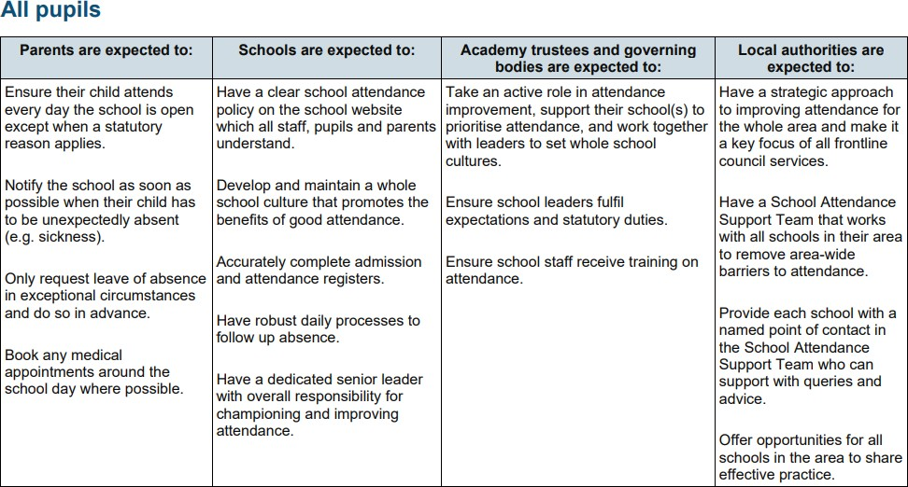

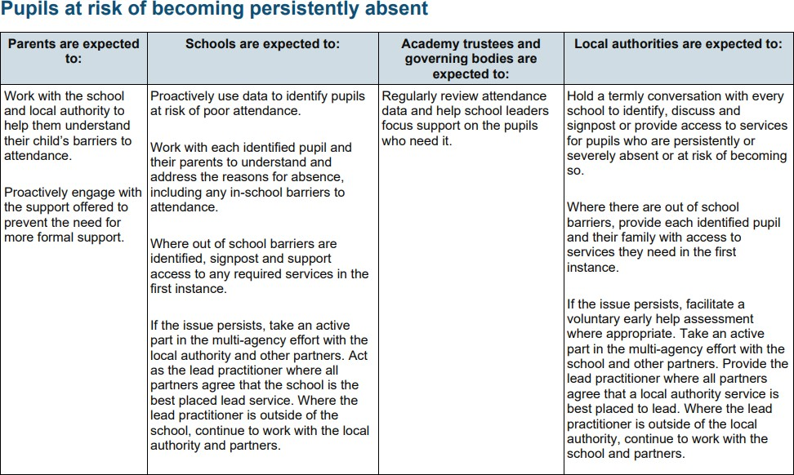

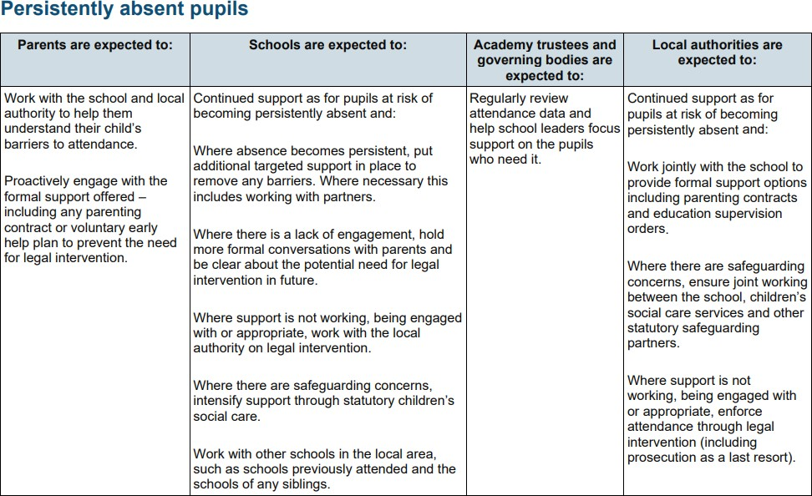

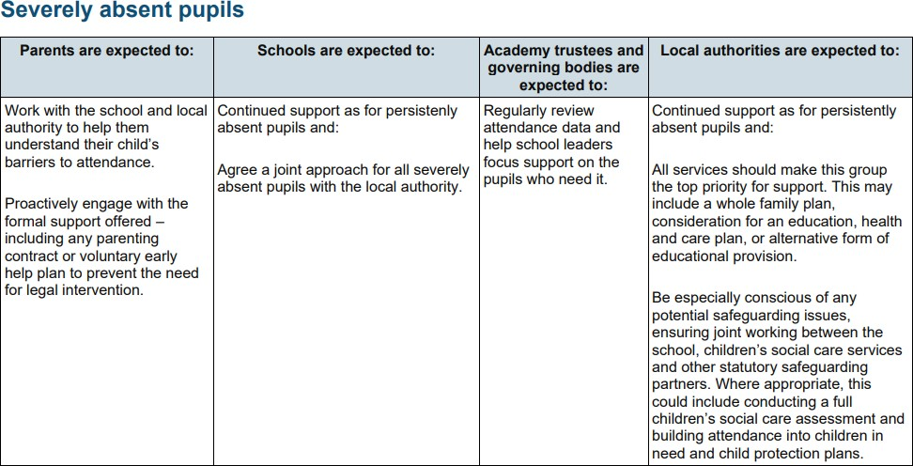

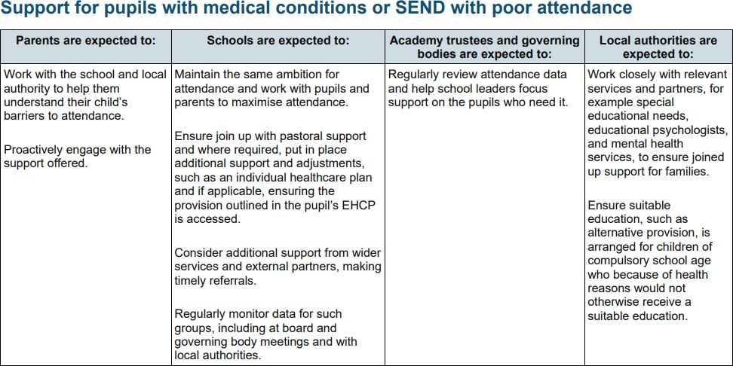

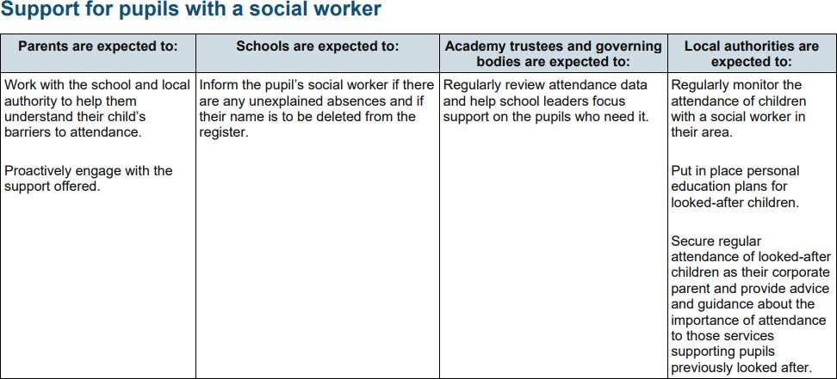

Annex B

ESSEX CODE OF CONDUCT
PENALTY NOTICES FOR PARENTS OF TRUANTS AND PARENTS OF PUPILS EXCLUDED FROM SCHOOL
ANTI-SOCIAL BEHAVIOUR ACT 2003 SECTION 23
The purpose of this local code of conduct is to ensure that the powers are applied consistently and fairly across the Local Authority area to all Essex residents.

The Government requires Local Authorities to issue a code of conduct and any persons issuing Penalty Notices to a parent¹ must do so in accordance with this protocol. Essex County Council is legislatively responsible for administering the Penalty Notice scheme and will do so in accordance with a number of legislative and non-legislative requirements.

The Essex code has been agreed following consultation with;

- Essex County Council representatives – Attendance Compliance Team and Essex Legal Services.
- Representatives from Governing Bodies and Headteachers of Essex Schools
- Essex Police
- Persons accredited under Essex Police’s Community Safety Accreditation Scheme (CSAS) The Code of Conduct is in accordance with the following legislation;
LEGISLATIVE FRAMEWORK FOR EDUCATION PENALTY NOTICES

The legal framework governing school attendance and the responsibilities of parents of excluded pupils, schools and the LA is set out in a succession of acts, regulations and other guidance.

Education Act 1996
Under Section 7 of the Act: the parent is responsible for making sure that their child of compulsory school age receives efficient full time education that is suitable to the child's age, ability and aptitude and to any special educational needs that the child may have, this can be by regular attendance at school, or otherwise (the parent can choose to educate their child themselves). If it appears to the LA that a child of compulsory school age is not receiving a suitable education, either by regular attendance at school or otherwise then they must begin procedures for issuing a School Attendance Order under Section 437 of the Education Act 1996.
If a child of compulsory school age who is registered at a school fails to attend the school regularly the parent is guilty of an offence under Section 444(1) of the Education Act 1996. In addition, if it can be proved that a parent knew of the child's non-attendance and failed to act, then they may be found guilty under Section 444(1 A). This offence (known as the higher or aggravated offence) can lead to a warrant being issued compelling a parent to attend court and conviction may result in a higher level fine and/or a custodial sentence.

¹ All those defined as a parent under Section 576 Education Act 1996 are parents for the purpose of these provisions. This means that all natural parents, whether they are married or not; any person who, although not a natural parent, has parental responsibility (as defined in the Children Act 1989) for a child or young person; and any person who, although not a natural parent, has care of a child or young person. Having care of a child or young person means that a person with whom the child lives and who looks after the child, irrespective of what their relationship is with the child, is considered to be a parent in education law. Parent means each and every parent coming within the definition (whether acting jointly or separately) and should not be taken to mean that provisions only apply to parent in the singular. As with prosecutions under Section 444 Education Act 1996 a penalty notice may be issued to each parent liable for the offence.

On 6 April 2017, in the case of Isle of Wight Council v Platt [2017] UKSC 28, the Supreme Court ruled
that the word ‘regularly’ means ‘in accordance with the rules prescribed by the school.’

Anti-social Behaviour Act 2003

http://www.legislation.gov.uk/ukpga/2003/38/contents

The Act added two new sections (444A and 444B) to the Education Act. It introduced penalty notices as an alternative to prosecution under Section 444; the issuing of penalty notices is governed by:

- The Education (Penalty Notices) (England) Regulations 2007
- The Education (Penalty Notices) (England) (Amendment) 2013
http://www.legislation.gov.uk/uksi/2013/757/contents/made

Children Act 1989

http://www.legislation.gov.uk/ukpga/1989/41/section/36

Crime and Disorder Act 1998

https://www.legislation.gov.uk/ukpga/1998/37/section/16

Education and Inspections Act 2006

http://www.legislation.gov.uk/ukpga/2006/40/contents

The Education (Pupil Registration) (England) Regulations 2006 (Amended 2013)

http://www.legislation.gov.uk/uksi/2013/756/regulation/2/made

AUTHORISATION TO ISSUE PENALTY NOTICES

Primary responsibility for issuing penalty notices rests with the Local Authority (LA). It has been agreed that the Attendance Compliance Team, on behalf of Essex LA, will usually issue penalty notices. The Service will administer the scheme from any funds obtained as a result of issuing penalty notices.

Head Teachers (and Deputy Head Teachers and Assistant Head Teachers authorised by the head teacher) and police, and persons accredited by the community safety accreditation scheme are all able to issue the notices under the Act, although there is no requirement for them to do so.

In Essex it has been agreed that the Police and Head Teachers will not issue penalty notices to parents. Persons accredited through the Community Safety Accreditation Scheme² are authorised to do so.

2 Accredited companies at time of this publication are Attendance Solutions Essex, Aquinas School Attendance Provisions and NEMAT Support Services

CIRCUMSTANCES IN WHICH A PENALTY NOTICE MAY BE ISSUED
Penalty Notices apply to pupils of statutory school age, which commences the term immediately following the child’s 5th
birthday and finishes on the last Friday in June of school year in which they turn 16.

Penalty notices will only be issued as a conclusion to a series of processes and when all attempts to address school attendance matters have been unsuccessful. If a previous Penalty Notice has been unsuccessful, rationale and justification should be provided as to why issuing another Penalty Notice would improve the attendance of the student. If schools are not aware of any previous or current legal interventions they must email attendancecompliance@essex.gov.uk . A response will be sent within 3 working days.
Parents cannot be penalised more than once for the same period of absence.

Domestic and European legislation and case law makes it clear that when serving a formal Notice in criminal proceedings, the recipient must be clearly and unambiguously identified. For the Purpose of issuing a Penalty Notice under this Code,
the parent’s first and last name must be cited on the Notice and any covering letter.
Essex partners have agreed to use Penalty Notices for the following circumstances however the offence under s444 Education Act 1996 is the same whether issued for unauthorised leave of absence (ULA) or irregular school attendance (ISA):

Penalty notices for unauthorised leave of absence (ULA)³

Penalty Notices may be issued where there have been at least 10 consecutive sessions of unauthorised absence for the purpose of a holiday, whereby a parent made an application to the School which the Head Teacher has deemed not for exceptional circumstances. In addition, a Penalty Notice may also be issued, whereby the parent did not submit a leave of absence request, however the school have reason to believe the absence was for the purpose of a holiday and should not be authorised as parent has not provided any additional evidence which the Head Teacher deems appropriate to support the absence.
In addition to the above criteria, due to the importance of pupils settling into school at the commencement of the school year, Penalty Notices may also be issued if there have been at least 6 consecutive sessions of unauthorised absence during the first two weeks of September due to a term-time holiday.

The Local Authority requests that for Penalty Notices to be issued, parents must be duly warned of the legal ramifications under separate cover if they remove their child from school for the purpose of a holiday. Schools/Academies must reference the use of Penalty Notices within their Attendance Policy which must be available to all parents/carers online and/or in hard copy within the school, accessible to parents to read. Schools should remind parents of the protocol regarding leave of absence during term time.

Penalty Notices for Irregular School Attendance (ISA)

Penalty Notices may be issued where there has been at least 10 sessions of unauthorised absence during the previous 10 school weeks.

Parents must have been issued with a Legal Action Warning Letter with accompanying Legal fact sheet and given opportunities to inform the school of any factors impacting on their ability to ensure their child attends school regularly. Warning letters are valid for 18 calendar weeks.

The Local Authority advises that the following template is used for irregular school attendance referrals as this has been specifically designed to enable the progression of cases if appropriate. This letter must be on headed paper from the school or accredited persons issuing the notice. The legal fact sheet must be included

3 Truancy/unauthorised/irregular school attendance refers to absence from school without permission or good reason and the absence is unauthorised by the school.

https://schools.essex.gov.uk/pupils/Attendance_Compliance/Documents/Legal%20Action%20Warning%20Letter%20for% 20schools.docx .

Failure to adequately issue warning to parents may result in the Penalty Notice being withdrawn or not issued.

All penalty notice referrals or notifications from Accredited Persons must be sent via Essex County Council’s online portal and all relevant pre-referral work in accordance with the Local Authority requirements must be uploaded alongside the referral/notification.

The Local Authority must be satisfied that the substantive offence in accordance with s.444 Education Act 1996 has been committed prior to issuing a Penalty Notice.
Evidence of attempts to address attendance concerns within the previous 8 weeks prior to requesting or notifying of a Penalty Notice must be submitted. Satisfactory evidence includes letters, notes of home visits, meetings, telephone calls etc.

N.B. for ULA and ISA PN’s consideration should always be given to whether it is appropriate to issue to absent parents.

Number of Penalty Notices which can be issued for Irregular school attendance/unauthorised leave of absence

Discretion will be used to enable up to two penalty notices to be issued to each parent for each child within a twelve month period. If the law continues to be broken around school attendance the Attendance Compliance Team may instigate legal proceedings.

Number of Penalty Notices which can be issued for pupils identified during a school attendance and exclusion sweep

School attendance and exclusion sweeps take place in Essex and children stopped are often with parents condoning the absence.

If the Head Teacher has not authorised the absence of a pupil stopped by a Local Authority Officer and Police Officer on a sweep and there has been at least 9 unauthorised absences for that pupil during the preceding 10 schools weeks, school will issue a legal action warning letter to the parent within 14 days. If there are any further unauthorised absences, during the following 18 calendar weeks a referral to the Attendance Compliance Team may be submitted for a Penalty Notice to be issued.

Essex will issue no more than two penalty notices to a parent in a twelve month period for pupils identified on a school attendance and exclusion sweep. If the law continues to be broken around school attendance the Attendance Compliance Team will instigate legal proceedings.

Excluded children

When a child is excluded from school, the parent will be responsible for ensuring that their child is not found in a public place during normal school hours on the first five days of each and every fixed period or permanent exclusion. (Section 103 Education and Inspections Act)

The excluding school must have notified the parent informing them of their duty and warning that a penalty notice could be issued.

Where there is more than one person liable for the offence, a separate penalty notice may be issued to each person.

Where a pupil is present in a public place in the first five days of a fixed period exclusion the Essex Local Authority would issue a penalty notice if the school is in their area. Where the child has been permanently excluded, it would be the authority where the child resides.

Number of penalty notices which can be issued for exclusion

Essex will issue a maximum of 2 penalty notices per parent for each child during a 12 month period.

Number of penalty notices which can be issued for unauthorised leave of absence

Essex will issue no more than two penalty notices to a parent in a twelve month period for unauthorised leave of absence. If the law continues to be broken around school attendance, the Attendance Compliance Team will consider further legal interventions.

PAYMENT OF PENALTY NOTICE

The penalty for each parent issued with a Penalty Notice is £120 for each child, however if paid within 21 days of receipt of the notice, it is reduced to £60. (Service by post is deemed to have been effected, unless the contrary is proved, on the second working day after posting the notice by first class post).
All penalties are paid to the LA and revenue generated is retained to administer the system and contribute towards s444 prosecutions following the non-payment of the Penalty Notice.
If the penalty is not paid in full by the end of the 28 day period, the Attendance Compliance Team will either prosecute for the offence to which the notice applies or withdraw the notice. The prosecution is not for non-payment of the notice but is a prosecution for irregular school attendance – Education Act 1996 Section 4441.

There is no statutory right of appeal against the issuing of a penalty notice.
WITHDRAWAL OF PENALTY NOTICE

A penalty notice may be withdrawn by the local authority named in the notice under the following circumstances:
- Where the local authority deems it ought not to have been issued i.e. where it has been issued outside the terms of the local code of conduct or where the evidence does not support the issuing of a penalty notice
- It appears to the local authority that the notice contains material errors
- Where it has been issued to the wrong person named as the recipient.

CO-ORDINATION BETWEEN THE LOCAL AUTHORITY AND ITS LOCAL PARTNERS

The Attendance Compliance Team and its local partners will review this Code of Conduct bi-annually unless local needs require otherwise.

VERSIONS

Original Code of Conduct was introduced in September 2004. Most recent revision - November 2017
Revised March 2019 for implementation from April 2019

Annex C

DfE “The link between absence and attainment at KS2 - 2013/14 academic year”

The analysis of the link between overall absence ….and attainment when taking prior attainment and pupil characteristics into account showed that, for each KS2 and KS4 measure, overall absence had a statistically significant negative link to attainment – i.e. every extra day missed was associated with a lower attainment outcome.

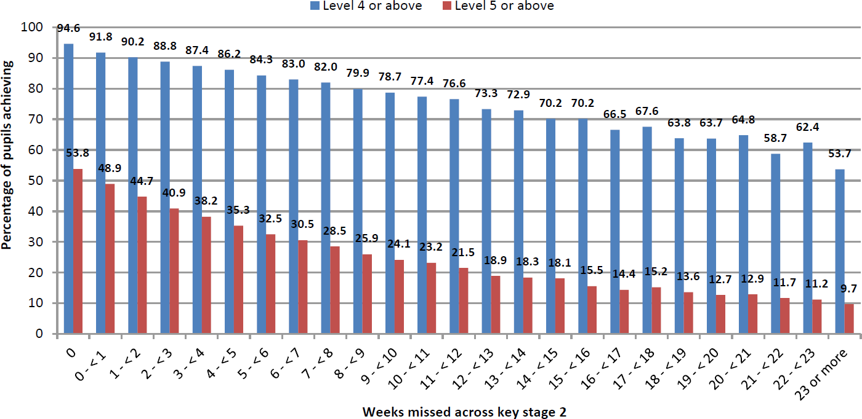

Appendix D

The name and contact details of the senior leader responsible for the strategic approach to attendance in our school is:

Add name role and contact as above

The name and contact details of the school staff member pupils and parents should contact about attendance on a day-to-day basis is:

Add name role and contact as above

